**Publish Over SSH Using Groovy**  
  
Open this github url to take the groovy script  
<https://github.com/jayanth197/AWS-DevOps.git>  
Click on Scripts  
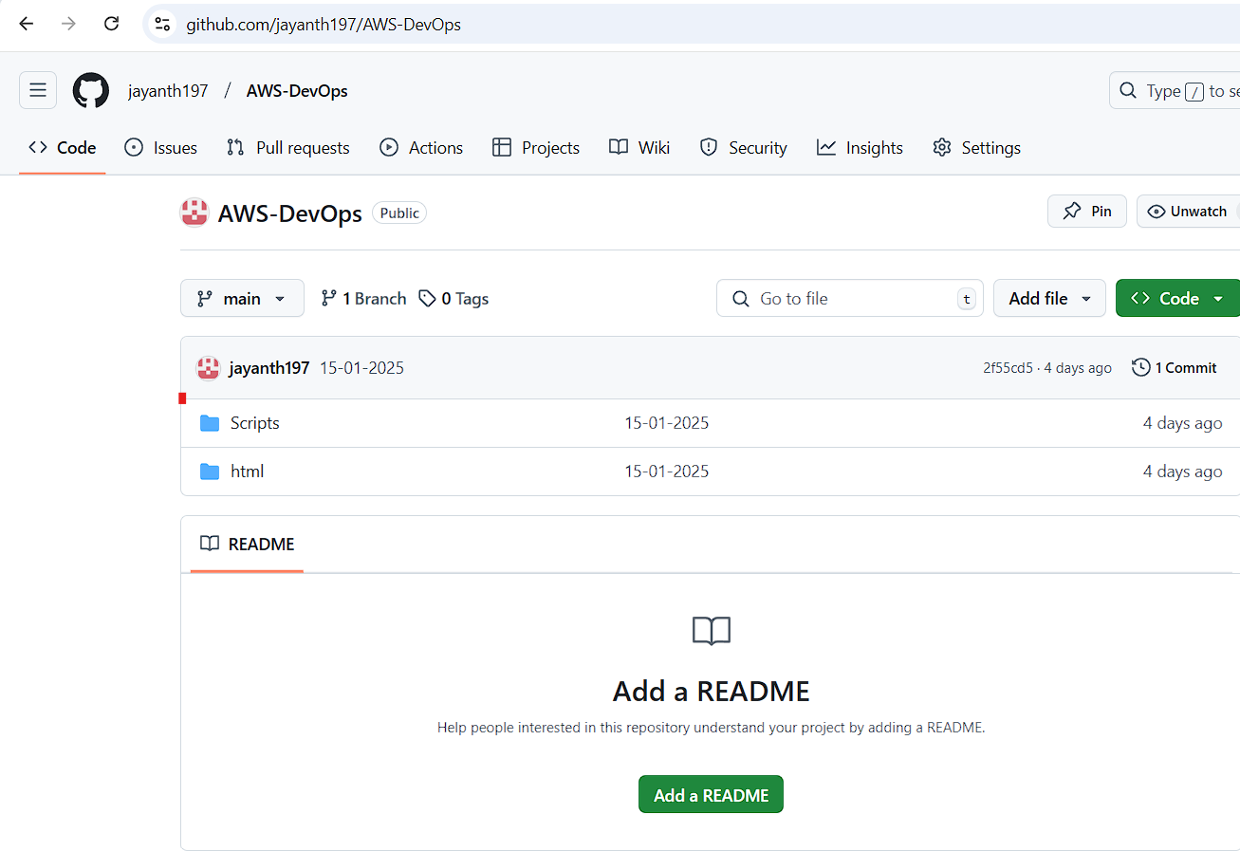  
  
  
Click on the Groovy-Script.groovy  
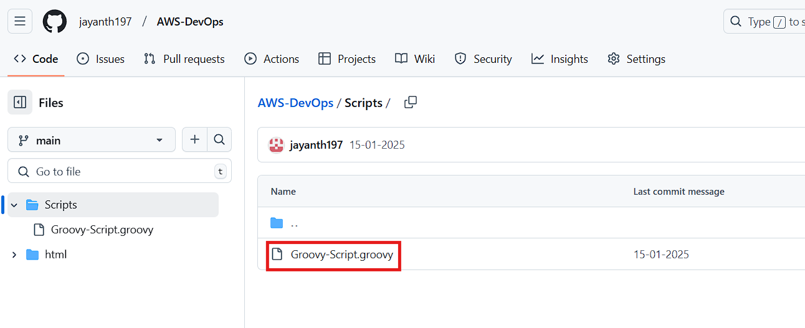  
  
  
  
  
  
  
Copy the script  
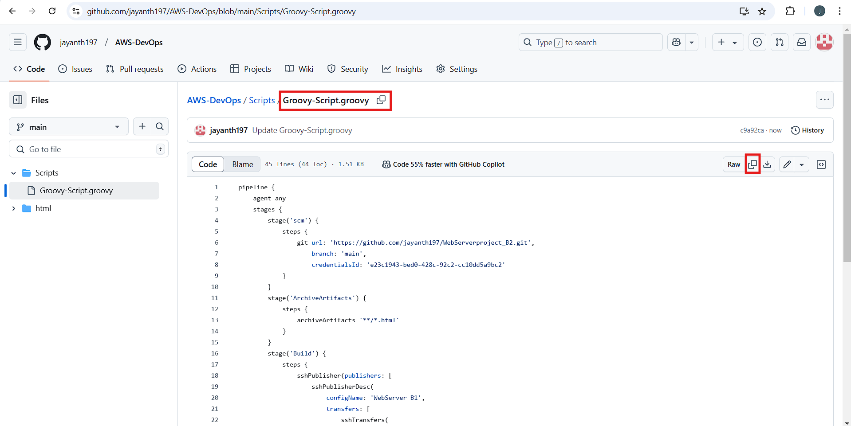  
  
Go to the Jenkins Dashboard and click on New Item  
  
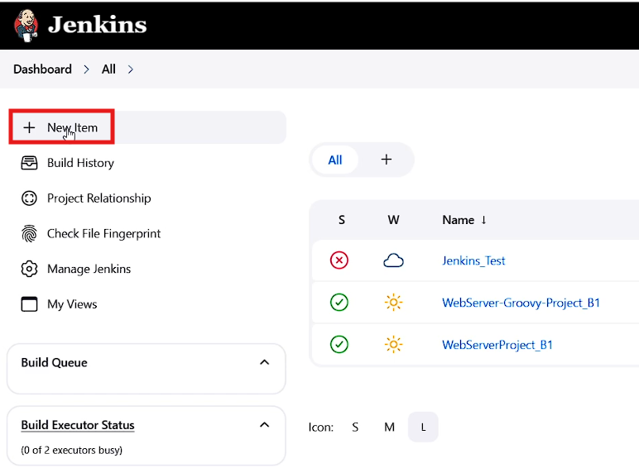  
  
  
  
  
Provide the required details as shown below  
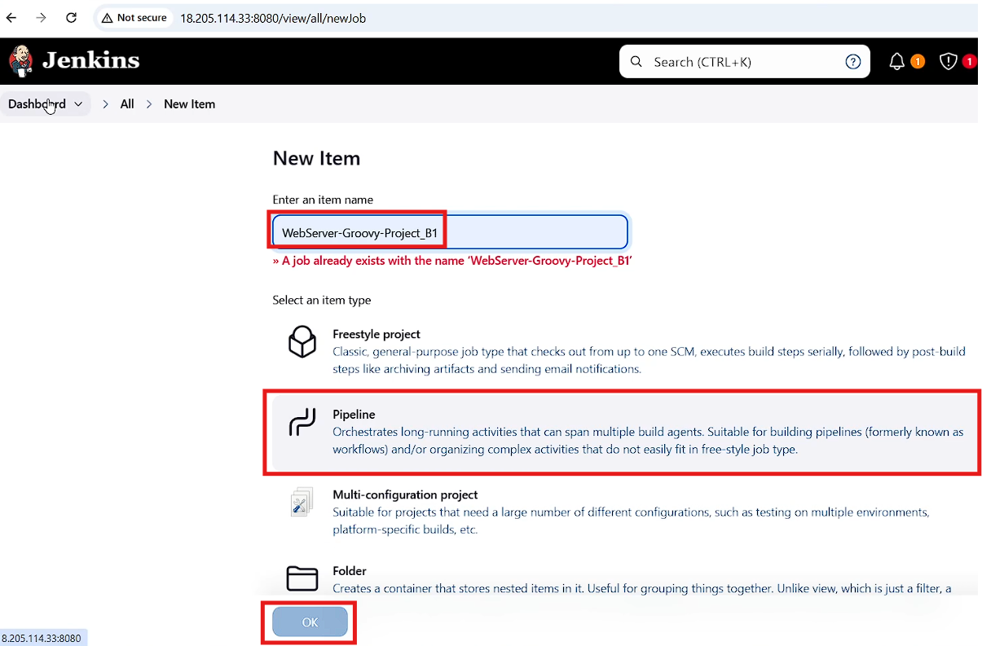  
  
  
In the pipeline section past the copied script and click on apply and save  
 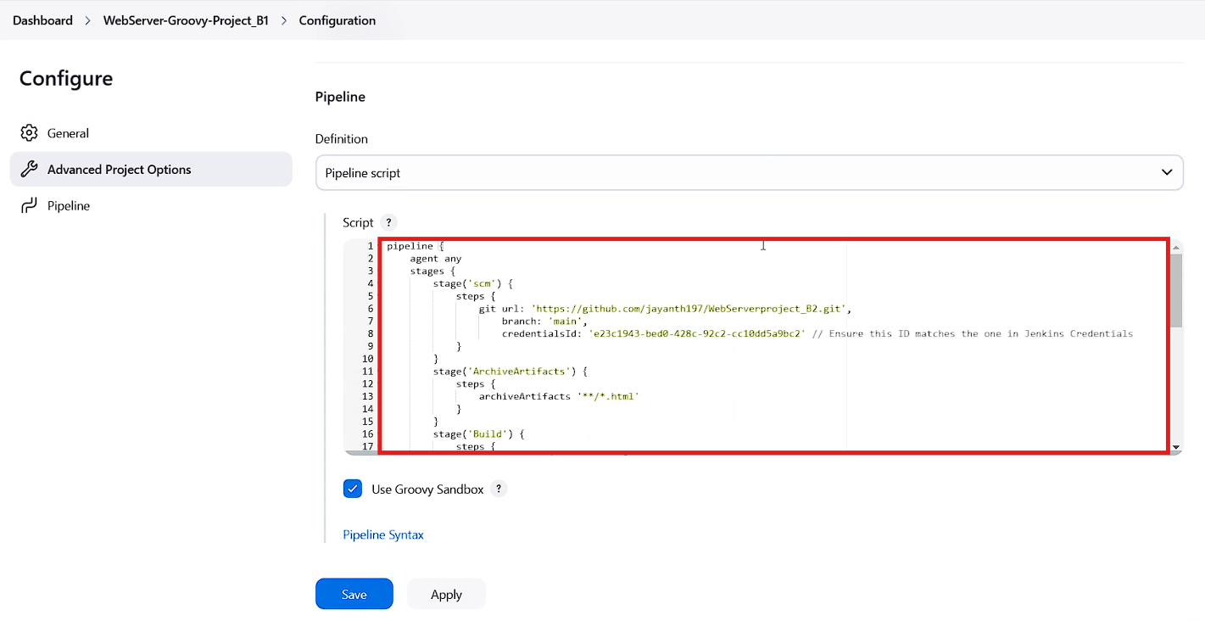  
  
  
  
  
  
  
Click on build now  
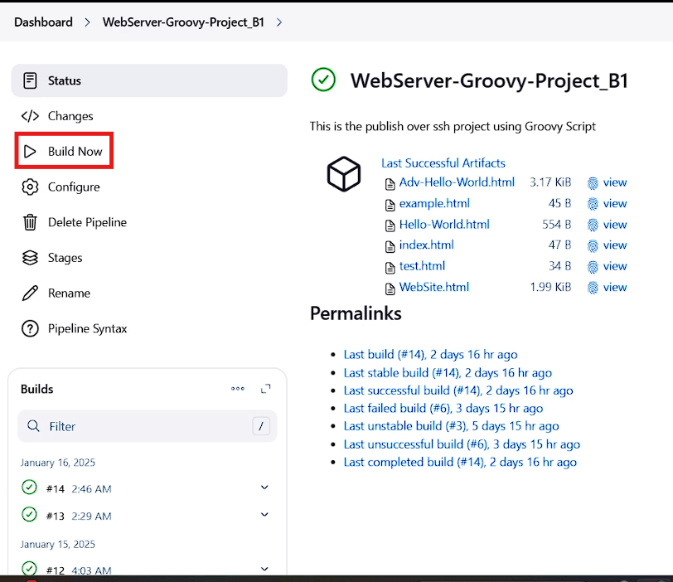  
  
  
once the build is successful copy the public ip of the webserver and search with the below example URL  
<http://(public> ip)/your html file  
then you will see the HTML pages in the browser  
